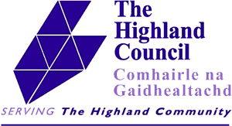
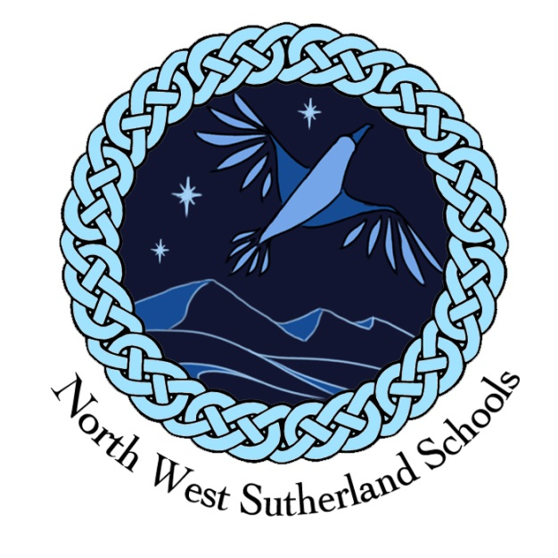

Dear Parent/Carer

Today sees the end of what has been the strangest term I or any of us have experienced in our teaching careers.
We should have had our high school prize giving yesterday and our annual sports day would have been held in the last few weeks but as you know these have not happened.
We plan to hold these events when we return to school if at all possible.
Prize giving will be a much scaled down affair and will happen on the first afternoon when we return on 11th August. Sadly, we will not be able to invite parents or members of the community but it is important that the achievements of this year are recognised and that certificates and trophies are awarded to some very deserving pupils. We will of course publish the list of prize winners after the event.
Sports day will happen as soon as we are able to do this safely and we will follow all Government and Council advice to ensure that everyone enjoys a safe day out.
I would like to thank all staff for their efforts this year. It has not been an easy year for any of us but the work and effort of all our teachers and non-teaching staff to support our pupils has been incredible and the last few months have made me very proud of our schools and all who work in them.
I wish all our pupils and their parents a very good holiday and we hope to see everyone back on the 11th of August.

Graeme Smart
Head Teacher

